**Portfolio Comparison**

*Assumptions in this case:*

*- Yearly returns for any stock in the basket: Mean = 6%, Standard Deviation = 15%*

*- For any stock, the returns on two consecutive years are independent*

*- Returns on different stocks are independent.*

For Talisman product, the expected return under our assumptions is around 4.42% with capital protection. We can only expect 42.94% chance that our return could exceed 5%, which is not a rather exciting result for investors.

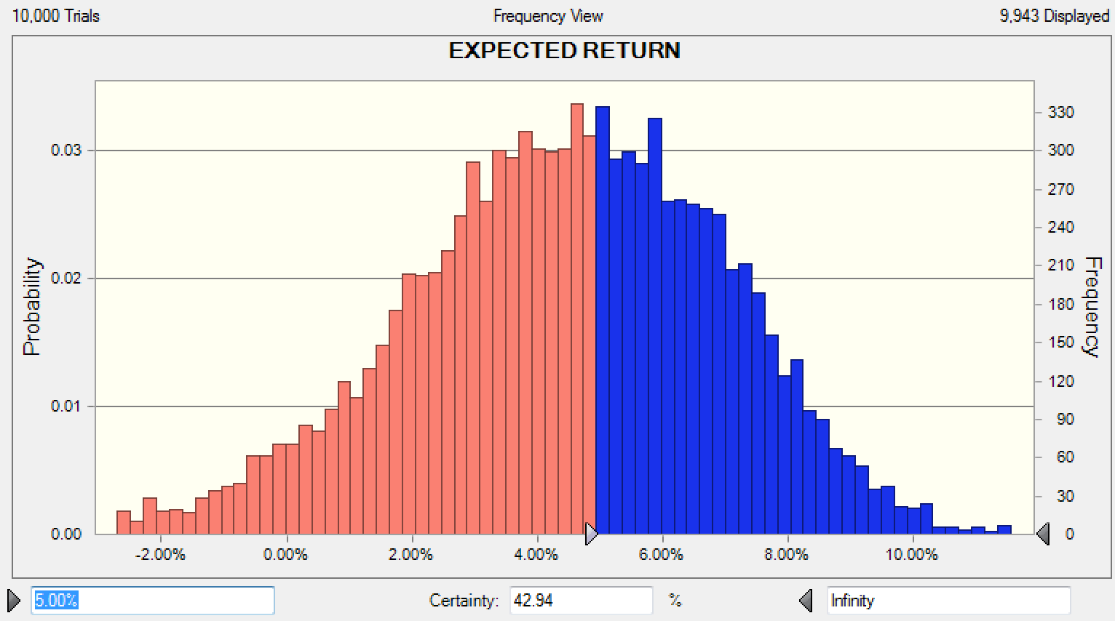

*Chart1: Frequency for Talisman Expected Return*

To find out how well this Talisman product is, we choose 25 stocks randomly in the same stock markets as Talisman do, without capital protection, to form a new portfolio as the reference group based on the same assumption. Here is the simulation result: (please see another excel file for this model)

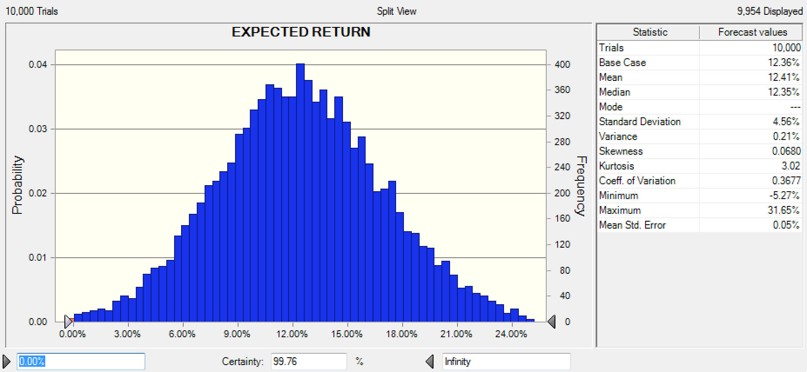

*Chart2: Frequency and Statistics for Randomly-chosen 25 stocks’ Expected Return*

According to the information above, it is clear that the main problem for the product, Talisman stock portfolio, is that it might never gain as much as the return when we buy 25 stocks randomly in those stock markets. Base on the model we build and regardless the real situation, the return of the stock portfolio which we choose randomly will be around 12%, way beyond 4.42% for Talisman portfolio. Furthermore, we can be 99.76% confident that the expected return of the portfolio we choose randomly is not negative, which is quite close to a capital protection.

So, based on the comparison analysis, it might not be a reasonable choice for investors to buy the Talisman stock portfolio, even for those risk averse investor.

The Talisman product is attractive for investors with limited budget, short investment time horizon and high-risk averseness. Other than money market funds which are very liquid and are specified as short-term investments, investments might require inaccessibility to the money invested for a certain period of time. Such time lines are typically 3 years, 5 years, 7 years, 10 years, 15 years, 20 years, 30 years, etc. for fixed rate investments. For stock investments, there might not be a defined lock-up time-frame but the longer the investment horizon, the higher the probability that investors make money. A 2-year investment is pretty short comparing with other types of investments which guarantee the principal amount. For such short-term investment, the suggested return seems pretty high. Therefore, investors who anticipate needing their money in the near future (less than 5 years) might find this investment very attractive.

A risk averse investor, would like to minimize his/her risk on the principal investment. Their investment type is closer to Treasury bills, Treasury bonds, corporate bonds, etc. Treasury bills are short-term and issued by government (backed by the government). They have minimized risk but the return on them is very low. If the investor seeks more return and is willing to take a little bit of risk, he/she will go with bonds which guarantee the principle and pay a higher amount of interest rate. Talisman investment is somehow similar to bond investments with slight differences. One problem with bonds is that they lock up the investors’ money for relatively long terms. However, Talisman only locks the investor’s money for 2 years. Although bonds seem to be a very safe investment, there are certain risks associated with bonds such as interest rate risk and inflation rate risk. If interest rates increase bond prices drop and the longer the term of the bond the sharper the drop. Since Talisman does not offer a fixed rate of return the interest rate risk would not be an issue.

When it comes to investing in stocks, portfolio diversity is very important. Obtaining a fair diversity in an investment portfolio, requires investment in different stocks. Investments in various stocks is costly because each trade comes with a fixed cost. If the amount of investment in the stock being traded is not big enough, trading costs will exceed the potential profit of the investment. Therefore, if investors don’t have large enough budget for investment, they can barely survive the volatile stock market. The Talisman structured product enables investors with assets of as low as 3000 euro to invest in a basket of stocks with a good amount of diversity. Therefore, people who have limited assets will find this product attractive.